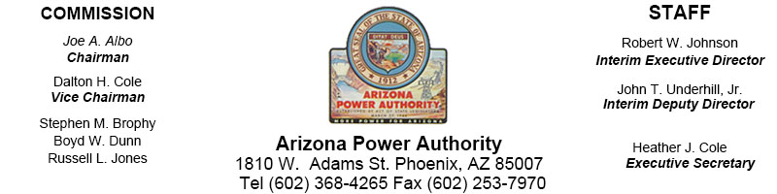
ARIZONA POWER AUTHORITY SPECIAL COMMISSION MEETING
September 9, 2016

Individuals wishing to attend the open portion of this Regular Commission meeting
by telephone may call in to (415) 655-0001, and use the Access Code 196 402 980#.

AGENDA

Items on this agenda may be discussed out of the order reflected below, unless they have been specifically noted to be set for a time certain. One or more members of the Commission may participate by telephonic, video, or internet communications.

The Arizona Power Authority does not discriminate on the basis of a disability regarding admission to public meetings. Persons with a disability may request a reasonable accommodation such as a sign language interpreter, by contacting Heather Cole, (602) 368-4265. Requests should be made as early as possible to allow time to arrange the accommodation.

CALL TO ORDER

PLEDGE OF ALLEGIANCE

ROLL CALL
DISCUSSION ITEMS (Possible Action)
  - Approval of a Consolidated Contract to Electrical District 4 which consolidates Post-2017 power previously awarded to each of Electrical District 4 & Electrical District 5 (Possible Action)
  - Approval of Western/APA Transmission Agreement (Possible Action)
  - Authorization of Commission Chairman to Execute Power Sales Contracts reflecting reallocation in accordance with 07.19.16 Reallocation Policy adopted by the Commission (Possible Action)
  - Review of Reallocation of Relinquished Power and Allocation Numbers
  - Review of Strategic Planning Retreat

COMMISSIONERS’ COMMENTS

VISITORS’ COMMENTS
- Visitors’ comments may be limited to no more than five (5) minutes per person and one person per organization

ADJOURNMENT
For items not specifically identified on the agenda, pursuant to A.R.S. § 38-431.01(H) Commission action taken as a result of public comment will be limited to directing staff to study a matter, responding to criticism, or scheduling a matter for further consideration and decision at a later date.

