Douglas A. Ducey Governor | Andy Tobin  Director
ARIZONA DEPARTMENT OF ADMINISTRATION
WATER QUALITY APPEALS BOARD
100 NORTH 15TH AVENUE • SUITE 103 PHOENIX, ARIZONA 85007
Telephone: (602) 542-1796
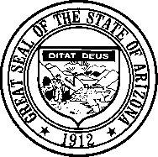

NOTICE AND AGENDA OF THE REGULAR MEETING AND EXECUTIVE SESSION OF THE ARIZONA WATER QUALITY APPEALS BOARD

Pursuant to Arizona Revised Statutes (A.R.S.) § 38-431.02, notice is hereby given to the members of the Water Quality Appeals Board and general public that the Arizona Water Quality Appeals Board (WQAB) will hold a regular meeting open to the public commencing on February 4, 2021 at 1:00p.m. Meeting will be held virtually.

The following options will be available for public attendance. Details on available options and associated instructions are included below:

Google Meet - Join by phone
+1 339-545-4648 PIN: 435 460 642#
Google Meet - Video link
http://meet.google.com/tsy-jpyc-gqd

**NOTE: Members of the public do not need to have a Google account to participate in this meeting. **

*Please note that members of the public that choose to utilize Google Meet must keep their microphone muted for the duration of the meeting. If a member of the public wishes to speak, they may unmute their microphone by pressing *6.

The agenda for this meeting follows. Any amendments or additions to the agenda will be available at least 24 hours prior to the meeting. The Board officer presiding at the meeting reserves the right to change the order of items on the agenda, except for public hearings set for a specific time.
Pursuant to A.R.S. § 38-431.03(A)(3), the Board may vote to go into Executive Session to obtain legal advice from its attorney on any matter listed on the agenda. Executive sessions are not open to the public.

Pursuant to Title II of the Americans with Disabilities Act (ADA), the WQAB will not discriminate on the basis of disability in admission to and observation of its public meetings. Persons with a disability may request a reasonable accommodation such as a sign language interpreter, by contacting the Board’s Office at (602) 542-1553. Requests should be made as early as possible to allow time to arrange the accommodation.

- Call to order and roll call

- 21-001 SWVP-GTIS MR Notice of Appeal of Agency Decision RE; Aquifer Protection Permit P-101704 (LTF 76820) Prehearing Conference.

- Declaration of Conflict of Interest
- Board Policy Regarding Electronic Filing of Documents
c. The Board will discuss and may decide on hearing this new appeal or submitting it to the Office of Administrative Hearings.
d. The Board may discuss and take action on setting deadlines, hearing dates, a briefing schedule for the pending Joint Motion to Dismiss and Alternative Motion to Hear Appeal and other procedural matters.

- EXECUTIVE SESSION – The Board may vote to go into Executive Session, which will not be open to the public, for legal advice concerning issues raised in the SWVP-GTIS MR appeal, as authorized by A.R.S. § 38-431.03 (A) (3).

DATED AND POSTED this 1st day of February 2021 at 4:00p

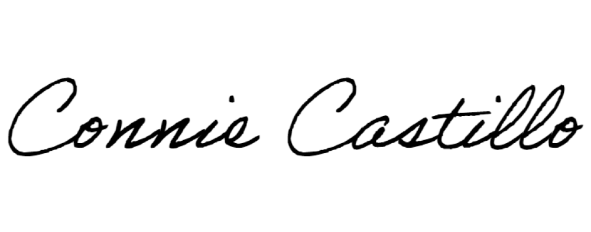
ARIZONA WATER QUALITY APPEALS BOARD

By: Connie Castillo, Clerk of the Board

A copy of the foregoing was mailed / emailed This 1st day of February 2021

ARIZONA WATER QUALITY APPEALS BOARD:
Fred E. Brinker, P.E. Keith Bowers

Dena R. Benjamin, Assistant Attorney General Arizona Attorney General’s Office
2005 N Central Ave., Phoenix, Arizona 85004
Attorney for the Water Quality Appeals Board

