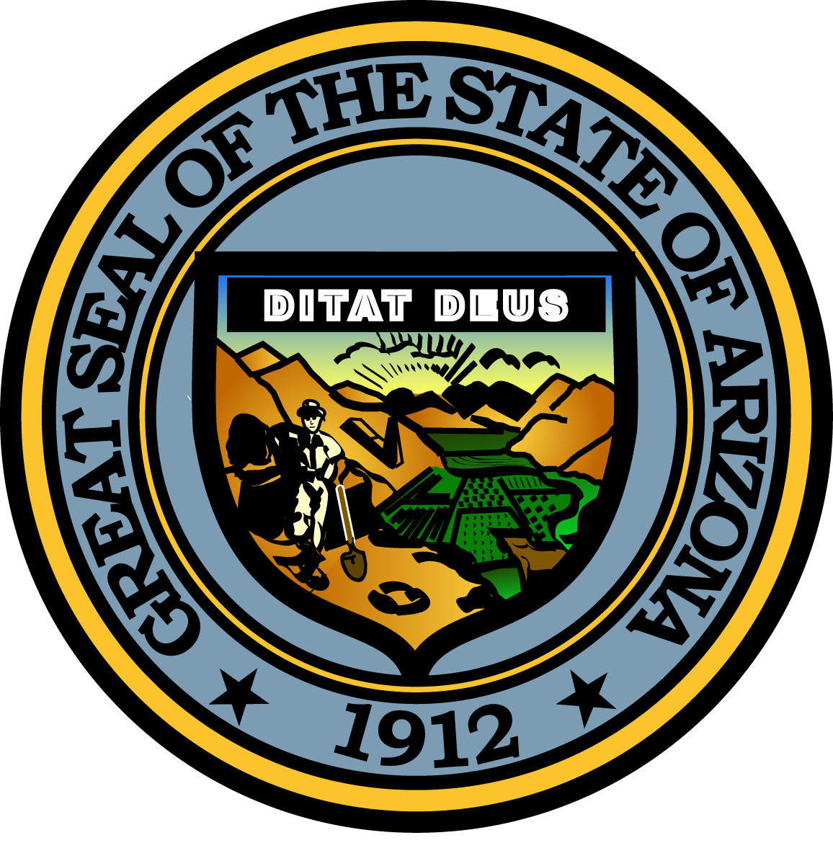

**ARIZONA JUVENILE JUSTICE COMMISSION**

**CHILD WELFARE COMMITTEE**

**March 30, 2016**

**1:00 PM**

**1700 W. Washington Street, Suite 230**

**Phoenix, Arizona 85007**

**Meeting Agenda**

|  |  |
| --- | --- |
| **Agenda Item** |  |
|  |  |
| 1. **Call to Order** | James Molina, Chair |
|  |  |
| 1. **Introductions** | All |
|  |  |
| 1. **Approval of Minutes** 2. **Committee Objectives – Next Steps**    * Establish Interagency Council    * Expand Trauma-informed Care Training    * Expand First Responder Training 3. **Technical Assistance and Membership Recruitment** 4. **Future Meeting Dates** | James Molina, Chair  James Molina, Chair  MMIC/DCS/Courts  Karrie Steving, MMIC  DCS/MMIC  James Molina, Chair  Steve Selover, JJ Specialist |
| 1. **Adjourn** | James Molina, Chair |

Pursuant to ARS 38-431.02 (A) (2), the Arizona Juvenile Justice Commission (AJJC) can vote to go

into Executive Session for the purpose of discussion or considering documents exempt by law from

public inspection and/or discussion or consultation for legal advice with its attorney.