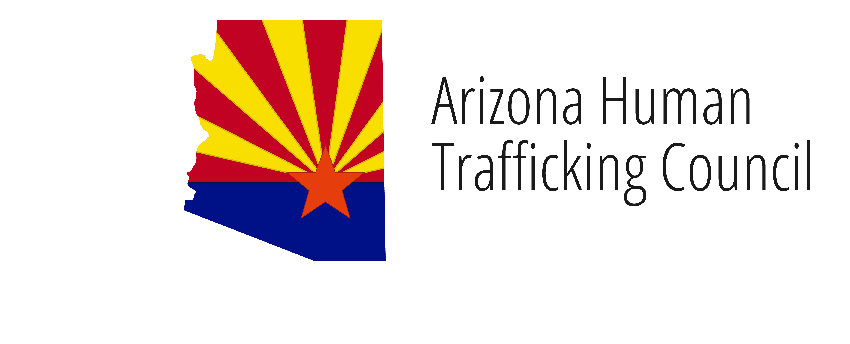

**Governor Ducey’s office of youth, faith and family**

*Arizona Human Trafficking Council*

**May 30, 2018**

**9:00 AM**

**Governor’s 2nd Floor Conference Room**

**1700 West Washington Street  
Phoenix, Arizona 85007**

Pursuant to ARS 38-431.02 (A) (2), the Governor’s **(Commission or Committee)** can vote to go into Executive Session for the purpose of discussion or considering documents exempt by law from public inspection and/or discussion or consultation for legal advice with its attorney.

Pursuant to A.R.S. § 38-431.01 (H), the Commission may obtain public comment pertaining to any of the listed agenda items if it so desires. A formal call to the public will take place at the end of the meeting.

**Meeting Agenda**

|  |  |
| --- | --- |
| **Agenda Item** |  |
|  |  |
| 1. **Call to Order\*** | Cindy McCain, Co-Chair  Gil Orrantia, Co-Chair |
|  |  |
| 1. **Introductions** | Co-Chairs |
|  |  |
| 1. **Approval of Minutes\***   April 4, 2018 | Co-Chairs |
|  |  |
| 1. **SESTA/FOSTA Update** | Yiota Souras Senior Vice President, General Counsel National Center for Missing & Exploited Children |
|  |  |
| 1. **Amber Alert** | Jim Waters  Amber Alert |
|  |  |
| 1. **Truckers Against Trafficking** | Don Blake  Inland, New Truck Sales Manager |
|  |  |
| 1. **Update on Navajo Nation** | Nathaniel Brown Navajo Nation Council Delegate |
|  |  |
| 1. **Subcommittee Report Outs** |  |
| 1. Outreach and Awareness Committee 2. Policy Committee 3. Training Committee 4. Victim Services Committee | Chief Gary McCarthy, Committee Chair  Sheila Polk, Committee Chair  Dr. Dominique Roe-Sepowitz, Committee Chair  Brian Steele, Committee Chair |
|  |  |
| 1. **Future Meeting Dates** | Co-Chairs |
| 1. September 11, 9am 2. October 31, 9am 3. December 12, 9am |  |
|  |  |
| 1. **Call to the Public** | Co-Chairs |
|  |  |
| 1. **Adjourn\*** |  |
|  |  |
| **\*ACTION ANTICIPATED** |  |
|  |  |