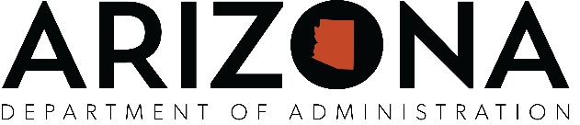

Arizona Set-Aside Procurement Program

TELEPHONIC MEETING

Meeting Agenda

**PUBLIC MEETING NOTICE**

**Agenda**

ARIZONA SET-ASIDE COMMITTE WILL HOLD A MEETING ON

**Tuesday, July 31, 2018 at 5:00– 6:00pm**

ADOA Conference Room 431

JOIN WEBEX MEETING  
[https://azgov.webex.com/azgov/j.php?MTID=mc0cf3252cfbeff2726874d8c8fc80932](https://www.google.com/url?q=https%3A%2F%2Fazgov.webex.com%2Fazgov%2Fj.php%3FMTID%3Dmc0cf3252cfbeff2726874d8c8fc80932&sa=D&ust=1533425572087000&usg=AFQjCNE1cVQx0bZIfJU-lyXPNFGpVu1FbA)

Meeting number (access code):  803 650 495  
Meeting password: 3pAduHhJ

JOIN BY PHONE  
+1-240-454-0879 USA Toll  
+1-240-454-0879 USA Toll

**Agenda**

1. CALL TO ORDER
2. ROLL CALL
3. Current Chair: Ed Jimenez, State Procurement Administrator
4. Current Member: Carr, Carol (ACHIEVE Human Services/YUMA WORC Center)
5. Current Member: Mackey, Kristen (Rehabilitation Services Administration)
6. Current Member: Brian Radecki (AZ Correctional Industries)
7. MEETING MINUTES APPROVAL
   * + - 1. Approval of March 29, 2018 minutes
8. CONTRACT RENEWALS
9. ADSPO17-155593 Sponges, Scrubbing & Scouring-SA - Stars (Expires: 7/31/18)
10. CNADI APPLICATIONS
    * + - 1. MY BLIND SPOT
11. FEASBILITY STUDIES
    * + - 1. Quality Connections feasibility study
12. CONTRACT APPLICATIONS
    * + - 1. None
13. COMMITTEE COMMENTS AND SUGGESTIONS
14. FUTURE AGENDA ITEMS
15. CALL TO THE PUBLIC
16. ADJOURNMENT
17. NEXT MEETING

For inclusion on the next regular agenda, contact Terri Johnson at (602) 542-5511. With prior notice to the State Procurement Office, committee members can appoint a proxy if they are unable to attend the meeting. If you require special accommodations, please contact the State Procurement Office at (602) 542-5511 at least three working days prior to the meeting.

|  |  |  |  |  |
| --- | --- | --- | --- | --- |
|  | Submitted by:  Barbara Corella  State Procurement Office |  |  |  |