**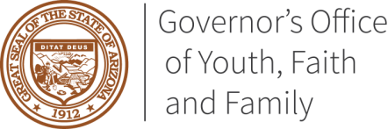***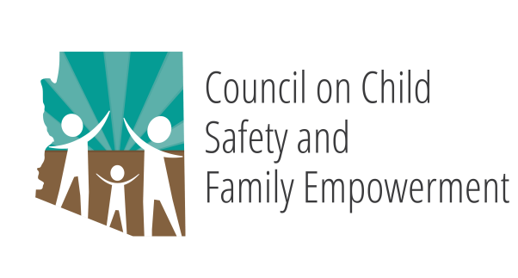*

**GOVERNOR DUCEY’S OFFICE OF YOUTH, FAITH AND FAMILY**

*COUNCIL ON CHILD SAFETY AND FAMILY EMPOWERMENT*

*African American Children & Families Subcommittee*

**April 19, 2019**

**10:00 AM**

**1700 West Washington Street Suite 230**

**Conference Room B**

**Phoenix, AZ 85007**

*Pursuant to ARS 38-431.02 (A) (2), the Governor’s* Council on Child Safety and Family Empowerment *can vote to go into Executive Session for the purpose of discussion or considering documents exempt by law from public inspection and/or discussion or consultation for legal advice with its attorney.*

*Pursuant to A.R.S. § 38-431.01 (H), the subcommittee may obtain public comment pertaining to any of the listed agenda items if it so desires. A formal call to the public will take place at the end of the meeting.*

**MEETING AGENDA**

|  |  |
| --- | --- |
| **Agenda Item** |  |
|  |  |
| 1. **Call to Order** | Roy Dawson, Subcommittee Chair |
|  |  |
| 1. **Opening Remarks and Welcome** | Roy Dawson, Subcommittee Chair |
|  |  |
| 1. **Introductions** | Subcommittee Members |
|  |  |
| 1. **Approval of Minutes**   March 15, 2019  March 21, 2019 (Focus Group) | Roy Dawson, Subcommittee Chair |
|  |  |
| 1. **Focus Group Report and Discussion** | Roy Dawson, Subcommittee Chair  Ginger Ward, Director, SWHD  Subcommittee Members |
| 1. **Future Meeting Dates** | Roy Dawson, Subcommittee Chair |
| May 17, 2019  June 21, 2019 |  |
| 1. **Call to the Public** | Roy Dawson, Subcommittee Chair |
|  |  |
| 1. **Adjourn** | Roy Dawson, Subcommittee Chair |