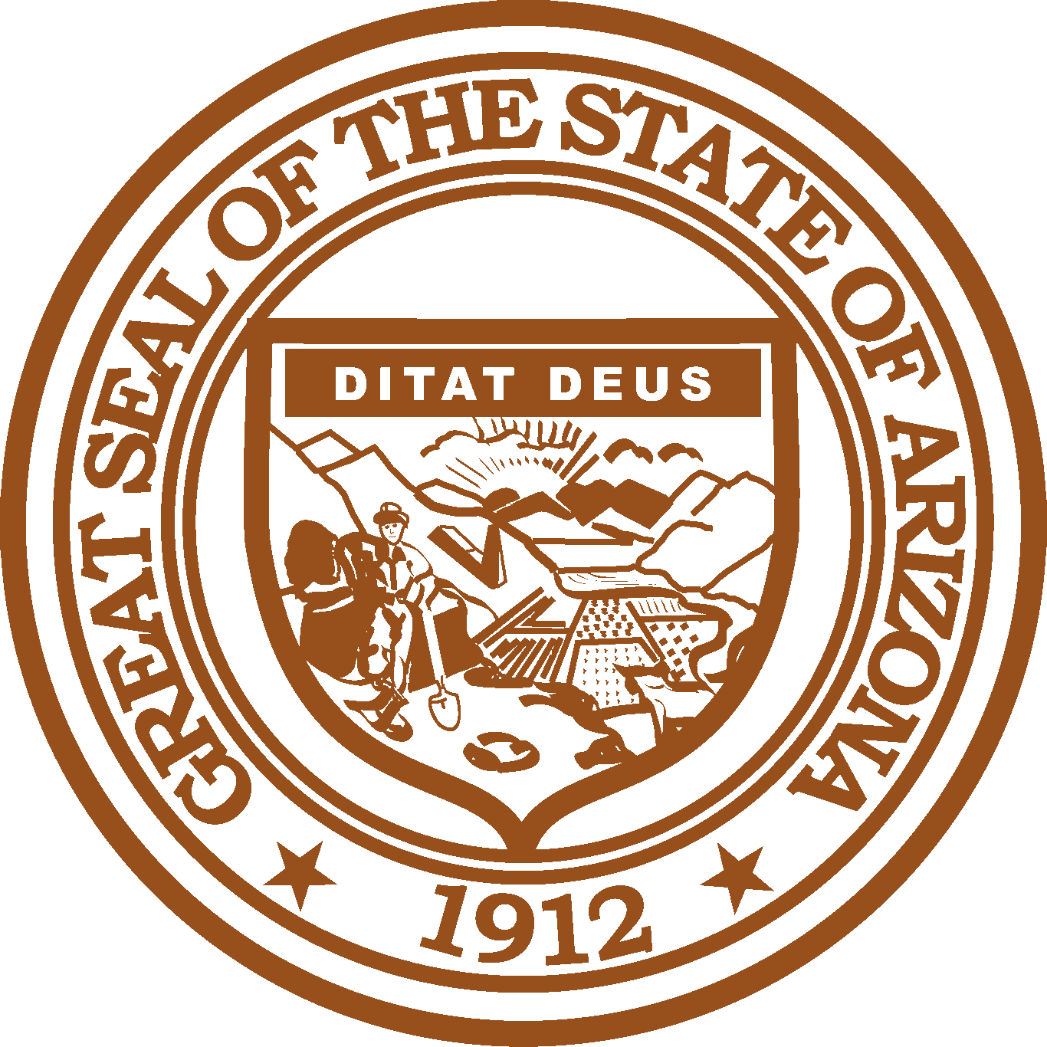
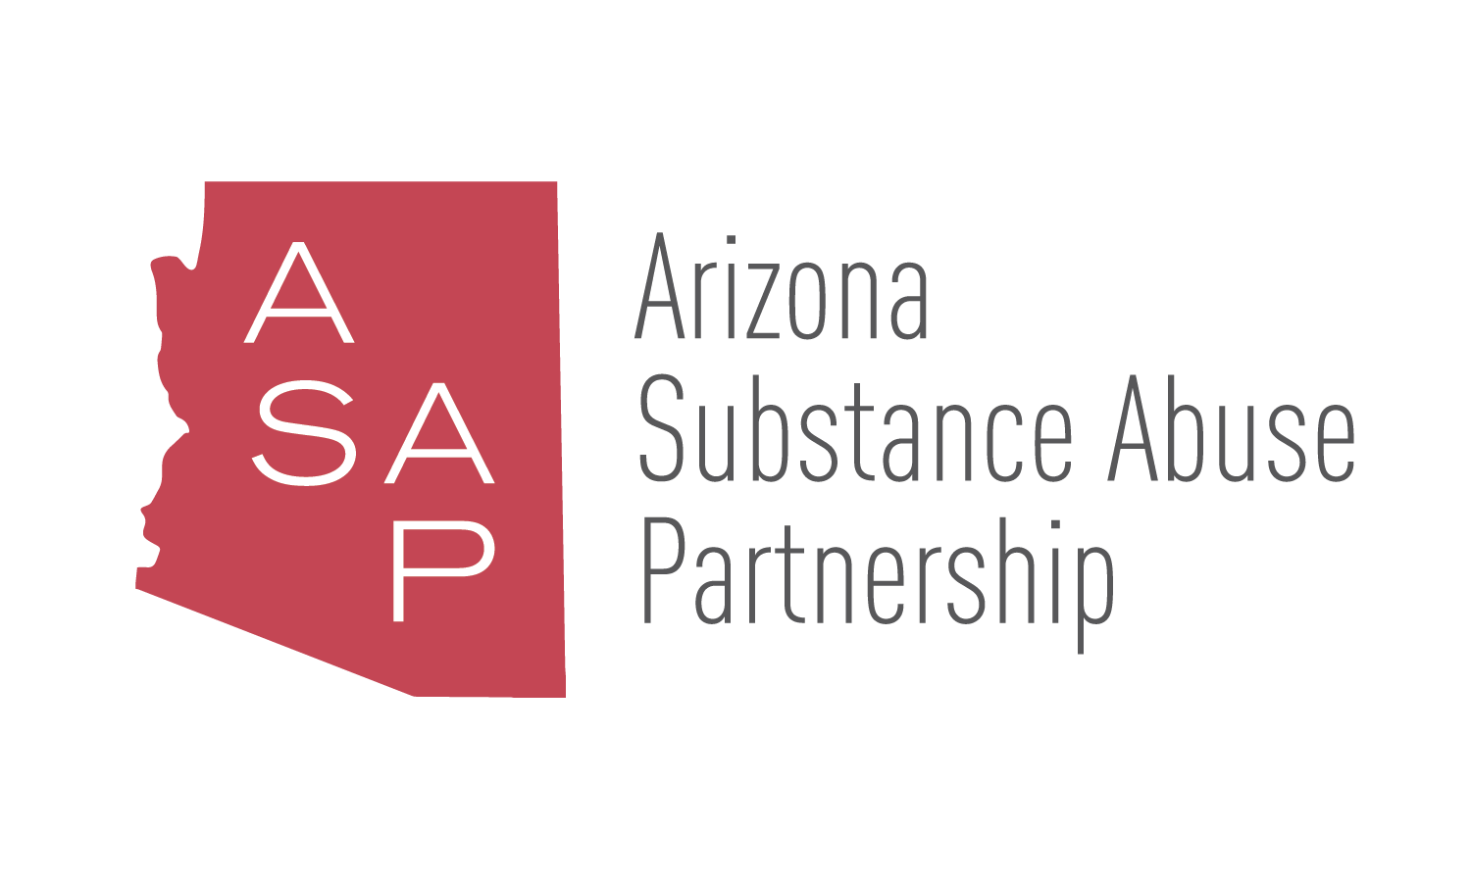

ARIZONA SUBSTANCE ABUSE PARTNERSHIP
August 31, 2017
2:00 PM
Governor’s Executive Tower
2nd Floor Conference Room
1700 West Washington Street
Phoenix, Arizona 85007

Pursuant to ARS 38-431.02 (A) (2), the Arizona Substance Abuse Partnership can vote to go into Executive Session for the purpose of discussion or considering documents exempt by law from public inspection and/or discussion or consultation for legal advice with its attorney.

Pursuant to A.R.S. § 38-431.01 (H), the Arizona Substance Abuse Partnership may obtain public comment pertaining to any of the listed agenda items if it so desires. A formal call to the public will take place at the end of the meeting.

Meeting Agenda
Agenda Item |  | Anticipated Action
- Call to Order* | Bill Montgomery, Chair | Action
- Welcome/Introductions* | Sam Burba, Vice Chair | Discussion
- Approval of Minutes* | Bill Montgomery, Chair | Discussion/Action
- GOYFF Updates  Red Ribbon Event  Recap of Harvey Milkman’s Speaking Event | Sam Burba, Vice Chair | Presentation
- Community Education Campaign | Tim Trull and Jennifer Whittle, LAVIDGE Company | Presentation
- Current State of Arizona’s Opioid Epidemic | Cara Christ, Az Dept of Health Services | Presentation / Discussion
- 2017 Drug Threat Assessment | James Ragan, AZ High Intensity Drug Trafficking Area | Presentation / Discussion
- Statewide Substance Abuse Strategic Plan | Bill Montgomery, Chair  Sam Burba, Vice Chair | Discussion
- Subcommittee Report Outs |  | Presentation / Discussion
- Recidivism Reduction Work Group  - Substance Abuse Epidemiology Work Group  - Program Inventory Work Group  - Prescription Drug Core Group  - Communication Work Group | Michael Mitchell, MCAO  Catie Clark, ACJC  Jim Kreitler, Calvary Recovery Center  Sam Burba, Vice Chair  Sam Burba, Vice Chair
- Future Meeting Dates | Sam Burba, Vice Chair | Discussion
- Thursday, October 12, 2017 from 2:00-4:00 pm
- 2018 Quarterly Meeting Dates
- Future Agenda Items | All | Discussion
- Call to the Public* | Bill Montgomery, Chair | Discussion
- Adjourn* | Bill Montgomery, Chair | Action

*Standing agenda item.

Arizona Substance Abuse Partnership meeting agendas are subject to change up to 24 hours prior to the meeting. Supporting documentation related to agenda items is available by contacting Jenna Shroyer, Program Administrator, Arizona Substance Abuse Partnership, Governor’s Office of Youth, Faith and Family at jshroyer@az.gov.

