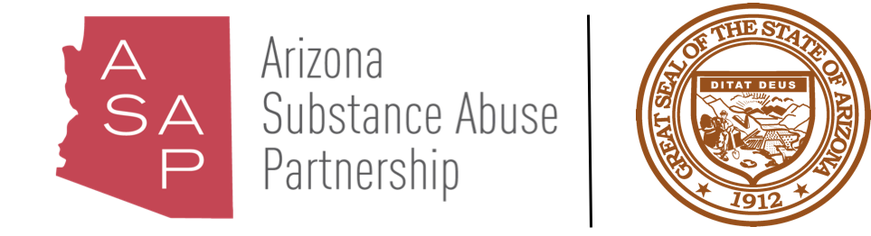

ARIZONA SUBSTANCE ABUSE PARTNERSHIP
PROGRAM INVENTORY WORKGROUP

June 27, 2019
1:00 PM
State Capitol Executive Tower
1700 W Washington Street, Suite 230
Phoenix, AZ 85007

Pursuant to ARS 38-431.02 (A) (2), the Arizona Substance Abuse Partnership can vote to go into Executive Session for the purpose of discussion or considering documents exempt by law from public inspection and/or discussion or consultation for legal advice with its attorney.

Pursuant to A.R.S. § 38-431.01 (H), the Arizona Substance Abuse Partnership may obtain public comment pertaining to any of the listed agenda items if it so desires. A formal call to the public will take place at the end of the meeting.

MEETING AGENDA
Agenda Item |  | Anticipated Action
Call to Order* | Merilee Fowler, Co-Chair | Action
Approval of Minutes* | Lee Pioske, Co-Chair | Discussion/Action
Substance Abuse Prevention Definition and National Prevention Network | Gabrielle Richard, Arizona Health Care Cost Containment System | Presentation/Discussion
Evaluating and Defining Outcomes for Substance Abuse Prevention | Wendy Wolfersteig, Ph.D., Arizona State University, Southwest Interdisciplinary Research Center | Presentation/Discussion
Meeting Dates | Merilee Fowler, Co-Chair | Discussion
Call to the Public* | Lee Pioske, Co-Chair | Discussion
Adjourn*  *Standing agenda item. | Lee Pioske, Co-Chair | Action

Arizona Substance Abuse Partnership meeting agendas are subject to change up to 24 hours prior to the meeting. Supporting documentation related to agenda items is available by contacting Samuel Burba, Director of Substance Abuse Initiatives, Governor’s Office of Youth, Faith and Family at sburba@az.gov.

