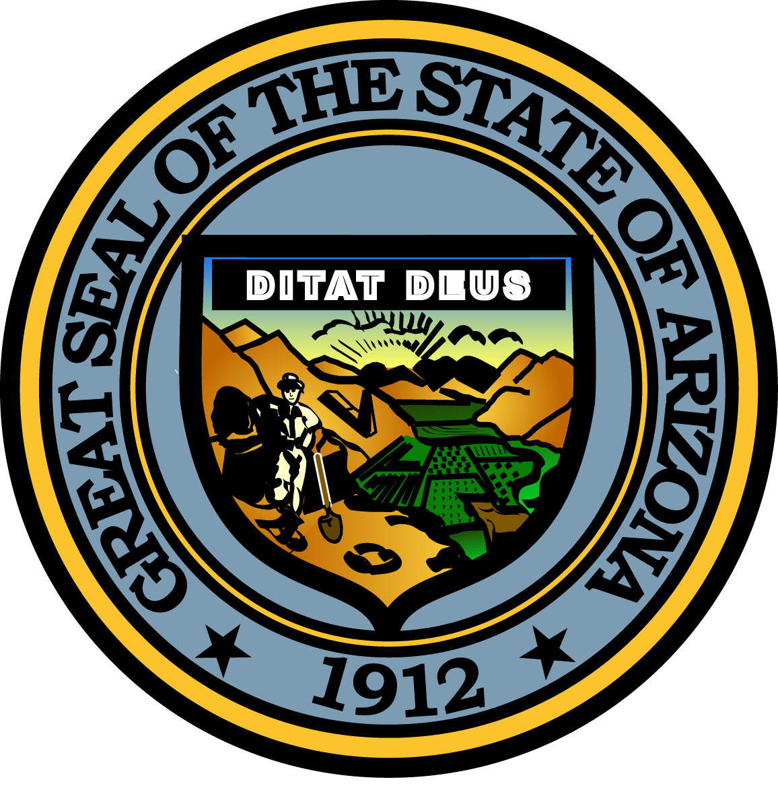

Governor’s Council on Child Safety and Family Empowerment

JANUARY 12, 2017

10:00 AM
1700 West Washington Street
The Executive Tower, 2nd Floor Conference Room
Phoenix, Arizona 85007

Pursuant to ARS 38-431.02 (A) (2), the Governor’s Council on Child Safety and Family Empowerment (Council) can vote to go into Executive Session for the purpose of discussion or considering documents exempt by law from public inspection and/or discussion or consultation for legal advice with its attorney.

Pursuant to A.R.S. § 38-431.01 (H), the Governor’s Council on Child Safety and Family Empowerment may obtain public comment pertaining to any of the listed agenda items if it so desires. A formal call to the public will take place at the end of the meeting.

MEETING AGENDA

Agenda Item

- Call to Order Kathryn Pidgeon, Co-Chair

- Opening Remarks by Chair Angela Ducey, Chair

- Introduction of Council Members Angela Ducey, Chair

- Approval of Minutes from November 10, 2016 Kathryn Pidgeon, Co-Chair

- Arizona Angel Initiative Sean Patrick Connolly, Commander
Phoenix Police Department, Maryvale-Estrella Precinct

- myCommunity Connect™ Pilot Program Kate Warren, Maryvale Onsite Coordinator
myCommunity Connect™

- Ending Family Homelessness Darlene Newsom, Chief Executive Officer
UMOM New Day Centers
Mattie Lord, Chief Program Manager
UMOM New Day Centers

- Giving Children a Voice Stacey Beck, Executive Director, Co-Founder
Pitch 4 Kidz

- Sub-Committee Reports:
-African American Children and Families Roy Dawson, Subcommittee Chair
-Outreach Paul Mulligan, Subcommittee Chair
-Partnerships Janet Garcia, Subcommittee Chair
-Prevention Vicki Mayo, Subcommittee Chair
-Support Kris Jacober, Subcommittee Chair

J. Call to the Public Angela Ducey, Chair

K. Future Meeting Dates and Adjournment Kathryn Pidgeon, Co-Chair
-March 9, 2017
-May 11, 2017
-September 7, 2017
-November 9, 2017

