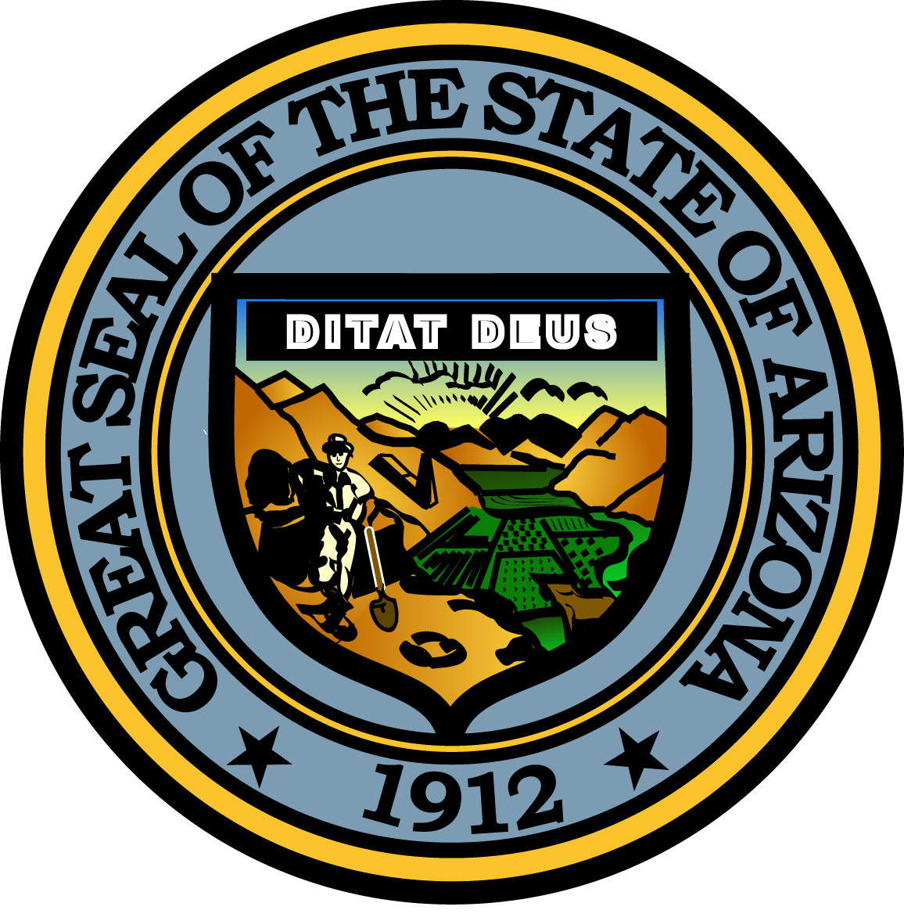

**Governor’s Council on Child Safety and Family Empowerment**

**NOVEMBER 10, 2016**

**10:00 AM**

**1700 West Washington Street**

**The Executive Tower, 2nd Floor Conference Room  
Phoenix, Arizona 85007**

Pursuant to ARS 38-431.02 (A) (2), the Governor’s Council on Child Safety and Family Empowerment (Council) can vote to go into Executive Session for the purpose of discussion or considering documents exempt by law from public inspection and/or discussion or consultation for legal advice with its attorney.

Pursuant to A.R.S. § 38-431.01 (H), the Governor’s Council on Child Safety and Family Empowerment may obtain public comment pertaining to any of the listed agenda items if it so desires. A formal call to the public will take place at the end of the meeting.

**MEETING AGENDA**

**Agenda Item**

1. **Call to Order**  Kathryn Pidgeon, Chair
2. **Opening Remarks by Chair** Angela Ducey, Chair
3. **Introduction of Council Members**  Angela Ducey, Chair
4. **Approval of Minutes from September 13, 2016**  Kathryn Pidgeon, Chair
5. **Arizona CarePortal and Angel Initiative Update** Debbie Moak, Director   
    Governor’s Office of Youth, Faith and Family
6. **Easing the Burden of Foster Families** Dan Shufelt, President & CEO

Arizona Helping Hands

1. **Department of Child Safety Update and Data**  Greg McKay, Director  
    Department of Child Safety
2. **Healthy Family Program** Susan Smith, Prevention Administrator

Department of Child Safety

1. **Christmas Tree Project** Terrilyn Miller, Director, Faith and Community Initiatives  
    Governor’s Office of Youth, Faith and Family

**J. Sub-Committee Reports:**

**-Prevention** Vicki Mayo, Committee Chair

**-Partnerships**  Janet Garcia, Committee Chair

**-Support**  Leslie Reprogle, Committee Chair

**-Outreach**  Paul Mulligan, Committee Chair

**-African American Children** Roy Dawson, Committee Chair

**K. Call to the Public** Angela Ducey, Chair

**L. Future Meeting Dates and Adjournment**  Angela Ducey, Chair

**-January 12, 2017**

**-March 9, 2017**

**-May 11, 2017**

**-September 7, 2017**

**-November 9, 2017**