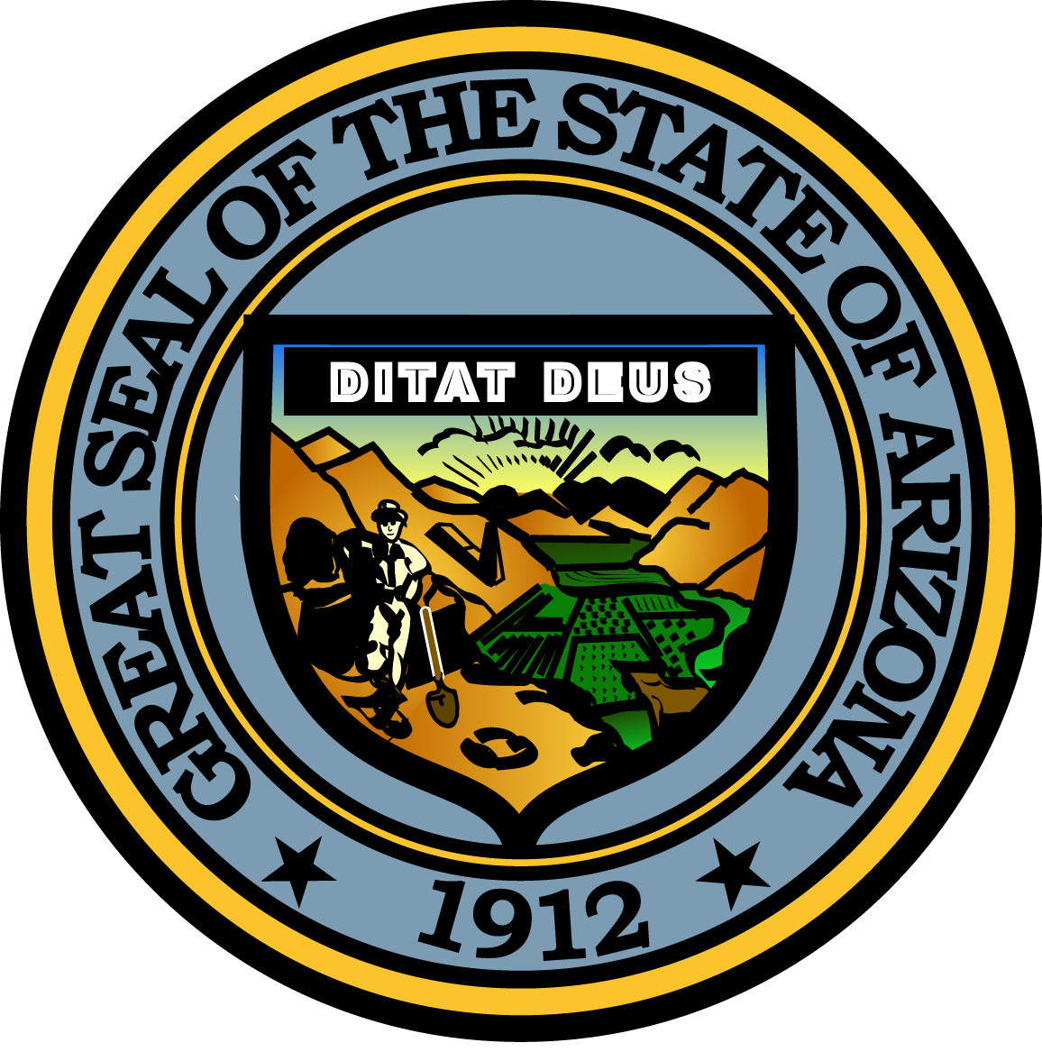

**Governor’s Council on Child Safety and Family Empowerment –**

**PREVENTION SUBCOMMITTEE**

**June 21, 2016, 3:00 p.m.**

**1700 W. Washington, suite 230**

**PHOENIX, AZ 85007**

Pursuant to ARS 38-431.02 (A) (2), the Governor’s Council on Child Safety and Family Empowerment (Council) can vote to go into Executive Session for the purpose of discussion or considering documents exempt by law from public inspection and/or discussion or consultation for legal advice with its attorney.

Pursuant to A.R.S. § 38-431.01 (H), the Governor’s Council on Child Safety and Family Empowerment may obtain public comment pertaining to any of the listed agenda items if it so desires. A formal call to the public will take place at the end of the meeting.

**DRAFT Meeting minutes**

|  |  |
| --- | --- |
|  |  |
| **Agenda Items:** |  |
| 1. **Review of notes from last meeting**   August 15th, 2016, is still the target launch date for the Angel’s Initiative Program in partnership with the City of Phoenix Police Department. High level notes to review from last meeting: RAP Unit, case management ready June 1st. Training of Angels completed. 4 RAP units available. Expanding to accommodate more during the pilot. Mark Upton of Christian Family Care gave Safe Families update. Mercy Maricopa update was provided. Commander Connolly of Phoenix Police Department spoke regarding thanks from the Police department.   1. **Assignment Reviews**   **- Materials to distribute including website creation** Decided not to launch with website. Let Maryvale Police Precincts process “presenters” as fast as the department can go. Continued discussion on what the best process for this will be. Biggest concern is that enough beds are available. Being proposed is a “soft launch”. Need to up uphold the integrity of initial intention of the program; voluntary surrender. Answers are in the community. Maryvale Revitalized; Maryvale YMCA org., Weed and Seed (10 Block watches) Justice Project. Darlene suggests community meeting (block party). Kick off press conference (October) might trigger attendance to a community meeting. Using soft launch prior to October statewide event and announcing Angels Initiative at Oct. function. Staggered approach…launching with 2 or 3 and if “no admits”, upping the number of providers/shelters. The Maryvale YMCA will be our first choice to community engagement. Then include the West Valley Human Service Alliance. Then the Faith and Justice project with Maryvale Police.  **-Marketing/Community Engagement materials (Darlene Newsom)**  **-Documents from Safe Families (Mark Upton)** Docs provided. One family recruited now. Looking for 8 teams. Looking at 30 churches in Maryvale. Intake forms provided for Safe Families. POA needs to be notarized…this is a concern. Forms should be available on line for anyone enrolling in Safe Families. Landing page should be included in marketing materials.  **-Bed Commitment from Salvation Army (Jeff Taylor)** Numbers are flexible. Jeff absent from meeting. Won’t know # of beds available. Late call from Jeff…# of beds 20  **-Mercy Maricopa Involvement Update (Jay Cory/ Lisa Lucchesi)**  Update from Alexandra O’Hannon of the Governor’s Office of Youth, Faith and Family. Jay Cory from Phoenix Rescue Mission will be meeting with them prior to July 12th meeting. Alex to update at next meeting with notes from Scarpati meeting. CHEERS was responsible for training of the Angels.   1. **Discussion and possible action on next steps to launch (Discussion to include public)**   **-Policy/Procedure drafted and trainings for Police Team and Angels** Maryvale police to do background check on Angels in vetting process. To assist Maryvale, need to do presentation during a briefing meeting. 15 minutes. Connolly or Egea to send agenda. Keep simple.  **-Marketing Campaign Launch** See comments above. Added by Jay, add comment the housing of children prior to surrendering to Angels. Also, Angel will be there within 30 minutes Phoenix Police Department not to provide transfer (future state).  **-Confirmation on beds/ research additional beds** Debbie Moak, Director of the Governor’s Office of Youth, Faith and Family, and Alex reaching out to community for additional space. New facility “Copper Stone” in Goodyear. Create “Roster of Honor” for those supporting the initiative.   1. **Call to the public** Any MOU w/ DCS. Not at this time. Agenda item: After Care. Metric ownership (GOYFF). Program success metrics. Reduction rates for OD, property (burglary, break in, shoplifting), child removal, simple drug arrests (possession only).Recidivism rates; before and after Angel Program 2. **Next meeting date and time – July 12th, 2016m 3pm at The Changing Lives Center – 338 N. 15th Avenue, Phoenix, AZ -** Marketing materials due at this meeting to be distributed after this meeting. (Shari to send Darlene flow sheet). 3. **Assignments for next meeting:**   -Review safe families doc (Mark Upton)  -Mercy Maricopa Update (Alexandra O’Hannon)  -Jay Cory to get names to Phoenix Police for vetting & come to next meeting w/ outcome metrics  -Penny Taylor to manufacture handout for PD (sending to Shari Crawford for review)  -Darlene Newsome and Billy Thrall to work on marketing materials and messaging to the community  -Mark Upton; Mapping of Areas  -MOU for DCS  **G. Meeting adjourned** | - |