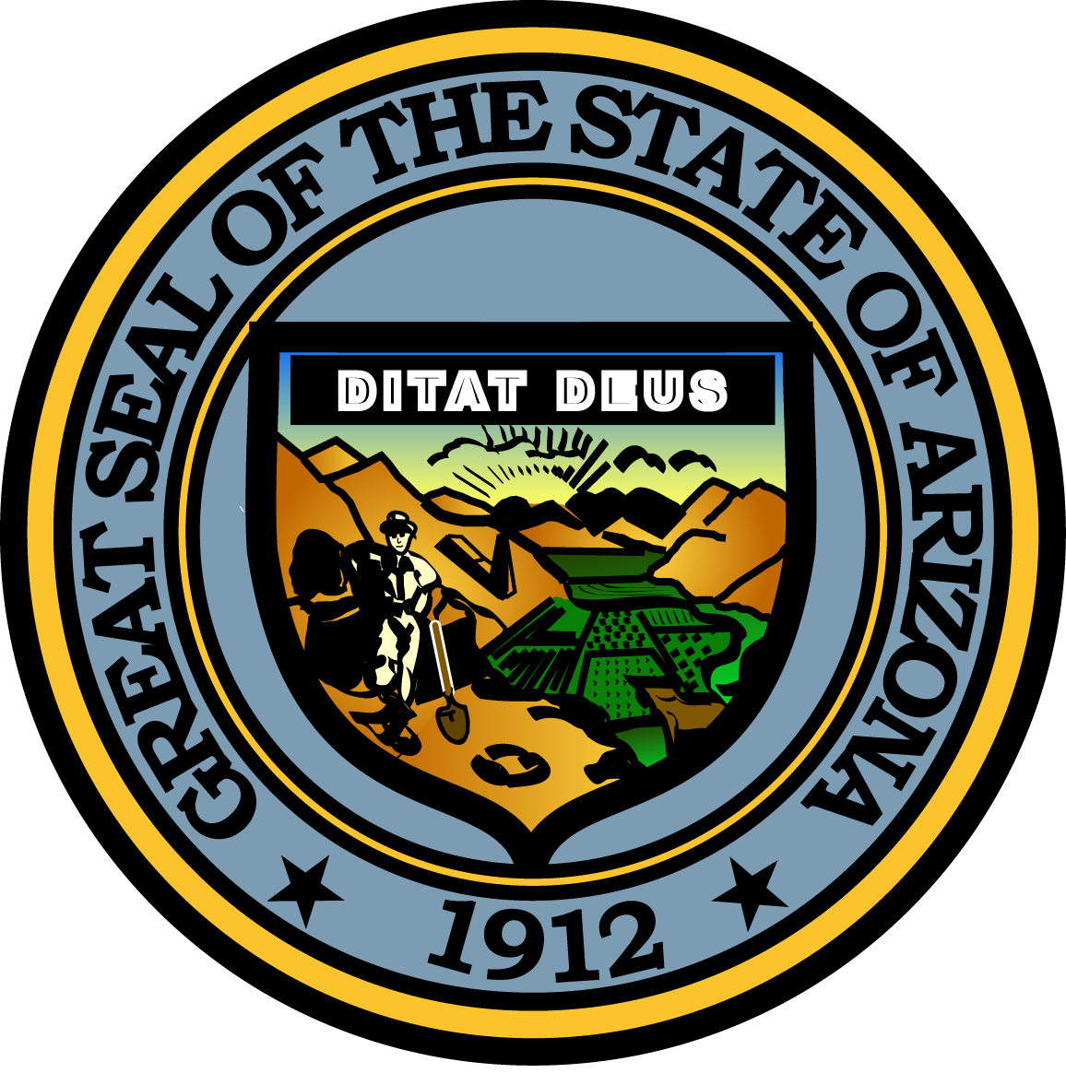

Governor’s Council on Child Safety and Family Empowerment –
support SUBCOMMITTEE

October 27, 2016

1:00 P.M.
Arizona Friends of Foster Children Foundation
1645 E. Missouri, suite 450
Phoenix, AZ, 85016

Pursuant to ARS 38-431.02 (A) (2), the Governor’s Council on Child Safety and Family Empowerment (Council) can vote to go into Executive Session for the purpose of discussion or considering documents exempt by law from public inspection and/or discussion or consultation for legal advice with its attorney.

Pursuant to A.R.S. § 38-431.01 (H), the Governor’s Council on Child Safety and Family Empowerment may obtain public comment pertaining to any of the listed agenda items if it so desires. A formal call to the public will take place at the end of the meeting.

Meeting Agenda

Agenda Items:
- Welcome / Introductions
- Review notes from this summer’s focus groups
- Next steps for objectives identified
- Next Meeting date
- Adjourn

