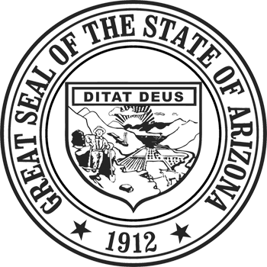
STATE OF ARIZONA
Department of Revenue

Property Tax Division
(602) 716-6843

Fax (602) 542-4425
Douglas A. Ducey
Governor
David Briant
Director
www.azdor.gov
1600 West Monroe Street, Phoenix, AZ 85007

NOTICE OF MEETING

EDUCATION, TRAINING AND CERTIFICATION ADVISORY COMMITTEE

Pursuant to ARS 38-431.02, notice is hereby given to the members of the Education, Training and Certification Advisory Committee and to general public that the Education, Training and Certification Advisory Committee will hold a public meeting on Friday, August 26, 2016 at 11:00 a.m.

The meeting will be held at the Arizona Department of Administration in conference room 101 located at 100 N. 15th Avenue, Phoenix, AZ 85007.

A copy of the meeting agenda may be obtained by calling (602) 716-6840.

Dated this 12th day of August, 2016

EDUCATION, TRAINING AND CERTIFICATION
ADVISORY COMMITTEE
JOLENE CHRISTOPHERSON, Secretary

Persons with a disability may request reasonable accommodations by contacting the Property Tax District at the Arizona Department of Revenue, (602) 716-6843. Requests should be made as early as possible to allow time to arrange accommodations.

