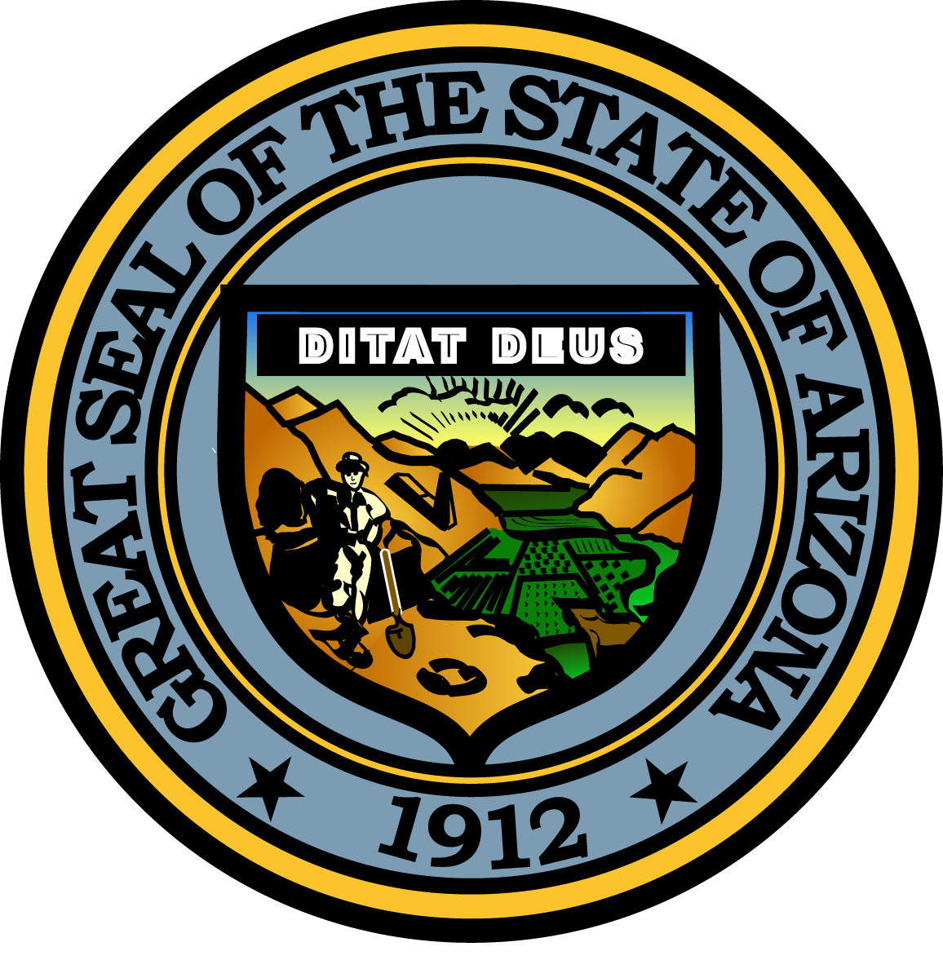

Governor’s Council on Child Safety and Family Empowerment

March 15, 2016

10:00 AM
1700 West Washington Street
The Executive Tower, 2nd Floor Conference Room
Phoenix, Arizona 85007

Pursuant to ARS 38-431.02 (A) (2), the Governor’s Council on Child Safety and Family Empowerment (Council) can vote to go into Executive Session for the purpose of discussion or considering documents exempt by law from public inspection and/or discussion or consultation for legal advice with its attorney.

Pursuant to A.R.S. § 38-431.01 (H), the Governor’s Council on Child Safety and Family Empowerment may obtain public comment pertaining to any of the listed agenda items if it so desires. A formal call to the public will take place at the end of the meeting.

MEETING AGENDA
Agenda Item

A. Call to Order Angela Ducey, Chair

B. Opening Remarks by Chair Angela Ducey, Chair

C. Introduction of Council Members All

D. Common Guidelines for Councils and Commissions John Raeder – Program Administrator
The Governor’s Office of Youth, Faith and Family

E. Overview and Initiatives - The Governor’s Office of Youth, Faith, and Family Debbie Moak - Director
The Governor’s Office of Youth, Faith and Family

F. Special Recognition Angela Ducey, Chair

G. Arians Foundation – CASA update Christine Arians
The Arians Foundation

H. Care Portal updates Billy Thrall – Faith and Community Initiatives Director
The Governor’s Office of Youth, Faith and Family

I. Sub-Committee Reports:
-Prevention Vicki Mayo, Committee Chair
-Partnerships Belen Gonzalez, Committee Representative
-Support Leslie Reprogle, Committee Chair
-Outreach Terry Crist, Committee Chair

J. Call to the Public Chair

K. Next meeting date (May 10th) Chair

L. Adjournment Chair

