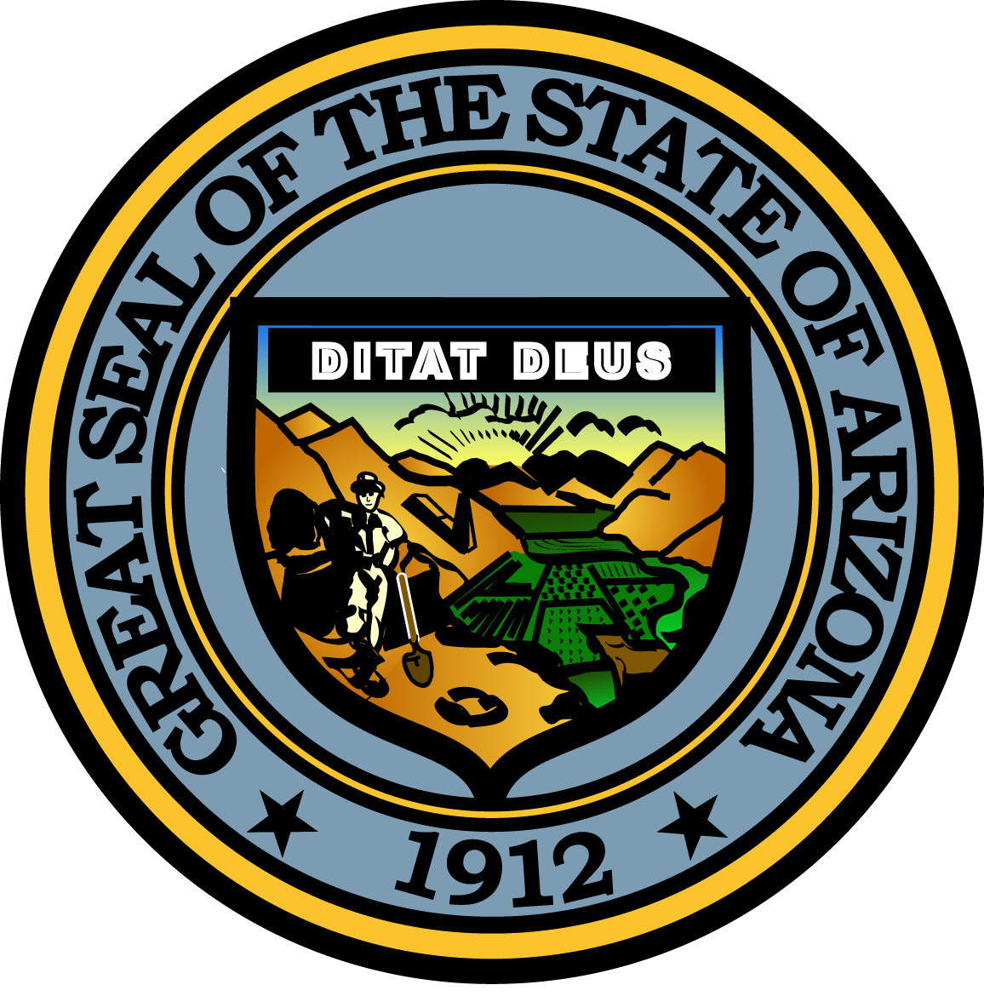

Governor’s Council on Child Safety and Family Empowerment

May 10, 2016

10:00 AM
1700 West Washington Street
The Executive Tower, 2nd Floor Conference Room
Phoenix, Arizona 85007

Pursuant to ARS 38-431.02 (A) (2), the Governor’s Council on Child Safety and Family Empowerment (Council) can vote to go into Executive Session for the purpose of discussion or considering documents exempt by law from public inspection and/or discussion or consultation for legal advice with its attorney.

Pursuant to A.R.S. § 38-431.01 (H), the Governor’s Council on Child Safety and Family Empowerment may obtain public comment pertaining to any of the listed agenda items if it so desires. A formal call to the public will take place at the end of the meeting.

MEETING AGENDA

Agenda Item

A. Call to Order Angela Ducey, Chair

B. Opening Remarks by Chair Angela Ducey, Chair

C. Introduction of Council Members All

D. Approval of Minutes Angela Ducey, Chair

E. Child Abuse Prevention License Plate Program John Raeder
Governor’s Office of Youth, Faith and Family

F. Special Recognition Angela Ducey, Chair

G. Care Portal Update for Maricopa County Billy Thrall
Governor’s Office of Youth, Faith and Family

H. Presentation – Safe Reductions Workgroup The Honorable Colleen McNally
Maricopa County Superior Court

I. Presentation – Arizona’s Children Association Denise Ensdorf, CEO

J. Presentation – Family Involvement Center Jane Kallal, Executive Director

K. Sub-Committee Reports:

-Prevention Jeff Taylor, Council Member
-Partnerships Belen Gonzalez, Council Member
-Support Leslie Reprogle, Committee Chair
-Outreach Paul Mulligan, Council Member

L. Call to the Public Angela Ducey, Chair

M. Future Meeting Dates (September 13th and November 10th) and Adjournment Angela Ducey, Chair

