Douglas A. DuceyCraig C. Brown
GovernorDirector
ARIZONA DEPARTMENT OF ADMINISTRATION

STATE PROCUREMENT OFFICE

100 NORTH FIFTEENTH AVENUE SUITE 201 PHOENIX, ARIZONA 85007
(602) 542-5511 (main) (602) 542-5508 (fax) http://spo.az.gov

PUBLIC MEETING NOTICE
ARIZONA SET-ASIDE COMMITTE WILL HOLD A MEETING ON
Wednesday, February 15, 2016 at 1:30 AM
100 N. 15th Ave., Phoenix, AZ 85007
1st Floor Conference Room

AGENDA
l. CALL TO ORDER
ll. ROLL CALL
APPROVAL OF MINUTES
October 19, 2016 minutes
- DISCUSSIONS
None
- Contract Items
ADSP014-065140 Engraved Products ACI
ADSPOI 5-086672 Signage: Decals, Plaques, & Work ACI
Identification Products
- APPLICATIONS AND FEASIBILITY REVIEWS (Possible action)
ADSP014-060351 Remanufactured & OEM Printer Supplies Quality Connections
Vil. COMMITTEE COMMENTS AND SUGGESTIONS
VIM. FUTURE AGENDA ITEMS
CALL TO THE PUBLIC
Set-Aside Committee Public Meeting Notice
Meeting Date: February 19, 2016
At this time, the subcommittee will hear comments from the public. Members of the subcommittee may not discuss items that are not specifically identified on the agenda. Therefore, pursuant to A.R.S. § 38431.01 (G), action taken as a result of public comment will be limited to directing staff to study the matter or scheduling the matter for future consideration and decision at a later date.
X. ADJOURNMENT
FOR SPECIAL ACCOMMODATIONS: Please contact Barbara Corella at (602) 542-9136 at least three working days prior to the meeting if you require special accommodations or if you cannot attend.
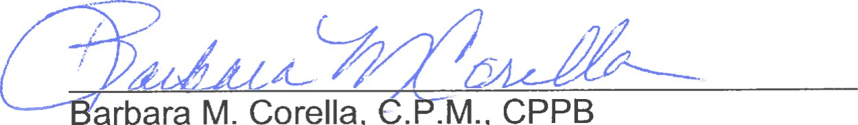
M.
Corella,
c.ï.M.,
State Compliance Officer State Procurement Office

