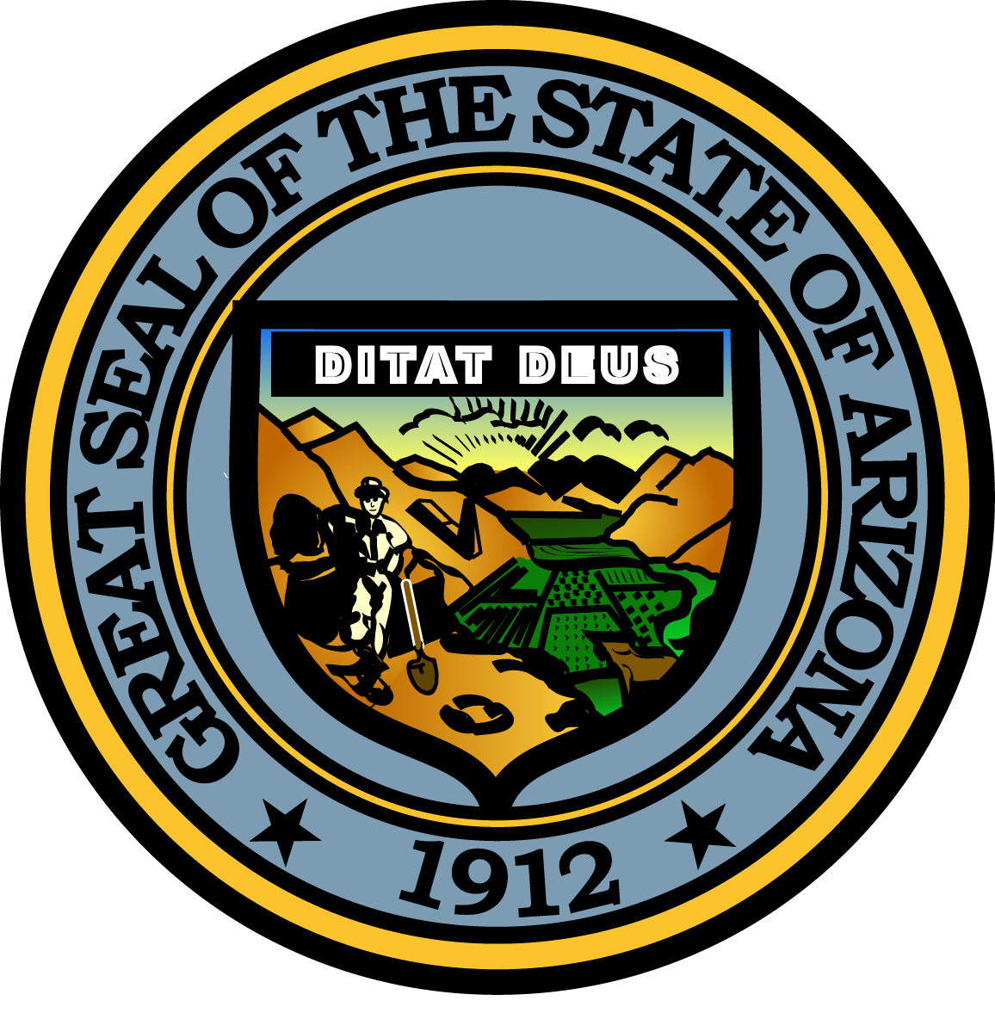

Arizona PARENTS COMMISSION ON DRUG EDUCATION AND PREVENTION

May 10, 2017
10:00 A.M.

ARIZONA STATE CAPITOL
1700 West Washington Street, Phoenix, AZ 85007
Executive Tower, First Floor Conference Room, Suite 105

Pursuant to ARS 38-431.02 (A) (2) and/or (A) (3), the Parents Commission can vote to go into Executive Session for the purpose of discussion or considering documents exempt by law from public inspection and/or discussion or consultation for legal advice with its attorney.

Pursuant to ARS 38-431.01 (G), the Parents Commission may obtain public comment pertaining to any of the listed agenda items if it so desires. A formal call to the public will take place at the end of the meeting.

Meeting Agenda

Agenda Item |  | Anticipated Action
- Call to Order | Joseph Leduc, Chair | Discussion
- Welcome/Introductions | Joseph Leduc, Chair | Discussion
- Approval of Minutes | Joseph Leduc, Chair | Discussion/Action
- March 8, 2017

- Amistades, Inc. - Familia Adelante Program | Melissa Gomez, Senior Project Coordinator | Presentation
- GOYFF Updates  - State Targeted Response to Opioid Crisis Grant  - Office of National Drug Control Policy (ONDCP) State Visit | Tonya Hamilton, Deputy Director, Governor’s Office of Youth, Faith and Family (GOYFF) | Discussion
- Approval of Operating Budget | Travis Price, Governor’s Accounting Office | Discussion/Action

- Recommendations for Grant Applications and Funding | Sonya Pierce-Johnson, Program Administrator, Governor’s Office of Youth, Faith and Family (GOYFF) | Discussion/Action
- Approval of Funding-RFGA -Renewals | Joseph Leduc, Chair | Discussion/Action
- Future Agenda/ Meeting Schedule | Sonya Pierce-Johnson, Program Administrator, Governor’s Office of Youth, Faith and Family (GOYFF) | Discussion
- Announcements | Joseph Leduc, Chair | Discussion
- Call to the Public | Joseph Leduc, Chair | Discussion
- Adjourn | All | Action

