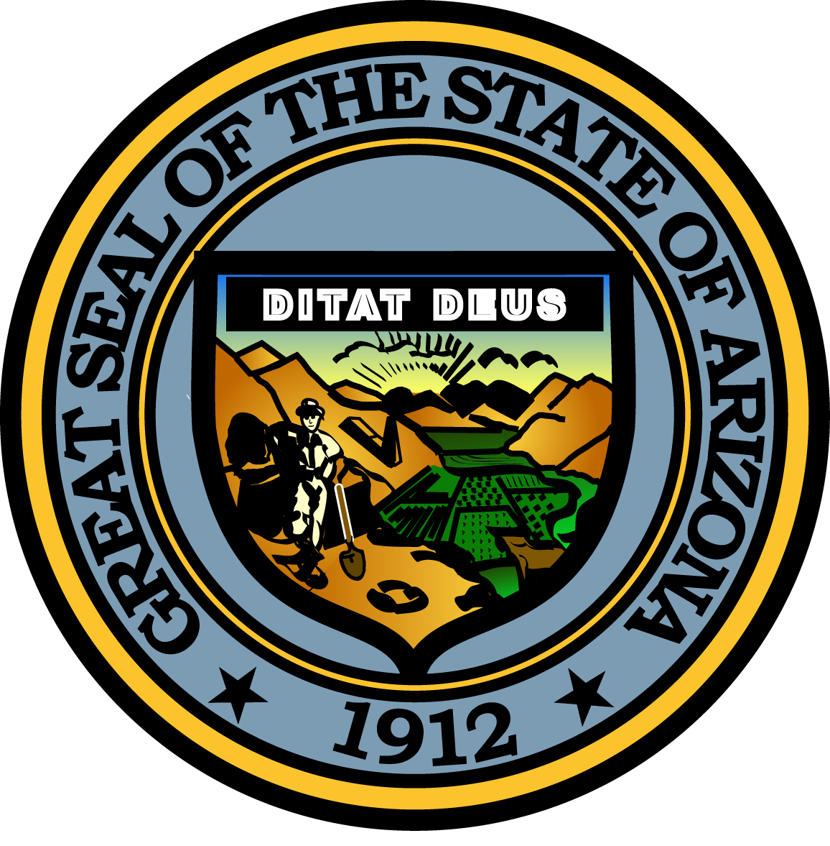
Governor’s Commission on Service and Volunteerism

High School Completion Committee

May 9, 2016
8:00 a.m.
via GoToMeeting

MEETING AGENDA

Agenda Item Anticipated Action

A. Call to Order Donna Martin, Chair

B. Welcome/Introductions All

D. Progress Since Last Meeting Donna Martin, Chair Discussion
Bob Shogren, AmeriCorps Director

F. Work Plan Updates Donna Martin, Chair Discussion

G. Next Steps Donna Martin, Chair Discussion

J. Call to the Public Donna Martin, Chair Discussion

K. Adjournment All Action

