Douglas A. Ducey  Governor | 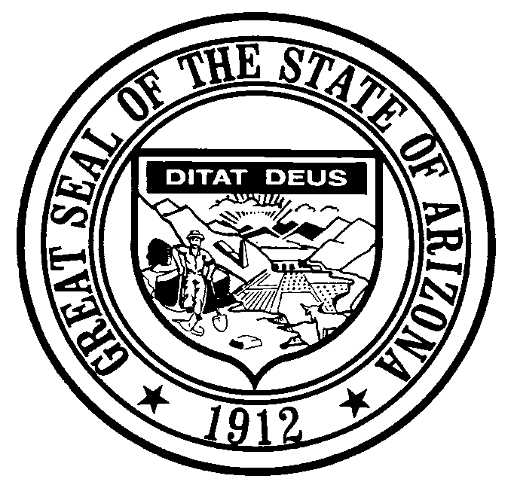 | Craig C. Brown  Director

ARIZONA DEPARTMENT OF ADMINISTRATION
STATE PROCUREMENT OFFICE
100 NORTH FIFTEENTH AVENUE • SUITE 201
PHOENIX, ARIZONA 85007
(602) 542-5511 (main) (602) 542-5508 (fax)
http://spo.az.gov

PUBLIC MEETING NOTICE

ARIZONA SET-ASIDE COMMITTE WILL HOLD A PUBLIC MEETING ON

Wednesday, October 19, 2016 at 1:30 PM

THE ARIZONA DEPARTMENT OF ADMINISTRATION
100 N. 15TH AVENUE, ADOA_300
Phoenix, Arizona 85007
_____________________________________________________________________
AGENDA
I. CALL TO ORDER

II. ROLL CALL

III. APPROVAL OF MINUTES

- March 22, 2016 sub committee meeting minutes
- July 29, 2016 committee meeting minutes

III. DISCUSSION (POSSIBLE ACTION)

- OVERVIEW OF STATE EXPENDITURES
- ESTABLISHMENT ON 1% GOAL TARGET
- VALUE ADDED SERVICE
- DRAFT DEFINITION OF MANDATORY

IV. CONTRACT EXTENSIONS

ADSPO14-0259582 Document Imaging Services Gompers
ADSPO15-090497 Office Supplies Quality Connections
ADSPO15-080052 Records Shredding & Destruction The Centers for
Services Habilitation
ADSPO15-088125 Records Shredding & Destruction Beacon Group SW
Services Inc.
ADSPO14-060351 Remanufactred & OEM Printer Quality Connections
Supplies

VI. APPLICATIONS AND FEASIBILITY REVIEWS

ADSPO12-013874 Officer Furniture ACI
ADSPO12-013712 Recycling Used Printer Cartridges Nobody’s Perfect

VII. COMMITTEE COMMENTS AND SUGGESTIONS

VIII. FUTURE AGENDA ITEMS

IX. CALL TO THE PUBLIC
At this time, the subcommittee will hear comments from the public. Members of the subcommittee may not discuss items that are not specifically identified on the agenda. Therefore, pursuant to A.R.S. § 38-431.01(G), action taken as a result of public comment will be limited to directing staff to study the matter or scheduling the matter for future consideration and decision at a later date.

X. ADJOURNMENT

FOR SPECIAL ACCOMMODATIONS: Please contact Barbara Corella at (602) 542-9136 at least three working days prior to the meeting if you require special accommodations or if you cannot attend.

_________________________________________
Barbara M. Corella, C.P.M., CPPB
State Compliance Officer
State Procurement Office

