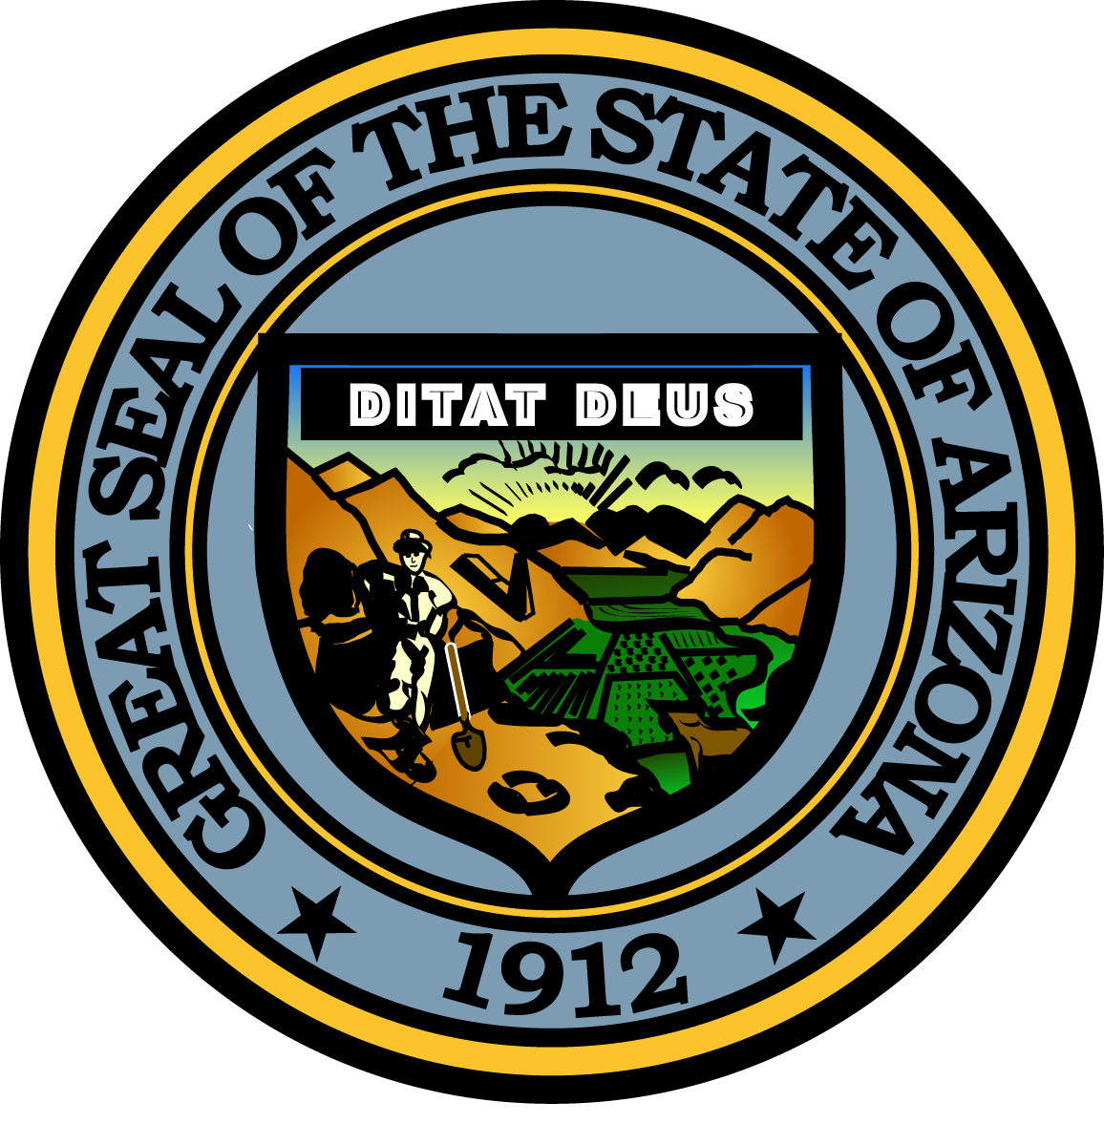

Governor’s Council on Child Safety and Family Empowerment –
PARTNERSHIP SUBC0MMITTEE
JANUARY 20, 2017

2:00 P.M.
Casey Family Programs Office
378 E. Palm Lane, Phoenix, Arizona, 85004

Pursuant to ARS 38-431.02 (A) (2), the Governor’s Council on Child Safety and Family Empowerment (Council) can vote to go into Executive Session for the purpose of discussion or considering documents exempt by law from public inspection and/or discussion or consultation for legal advice with its attorney.

Pursuant to A.R.S. § 38-431.01 (H), the Governor’s Council on Child Safety and Family Empowerment may obtain public comment pertaining to any of the listed agenda items if it so desires. A formal call to the public will take place at the end of the meeting.

Meeting Agenda

Welcome and Introductions Janet Garcia of Casey Family Programs

Review of Committee Charge and Goals Terrilyn Miller

2017 Planning Committee members

Member Updates Committee Members

Call to the Public Janet Garcia

Adjournment

