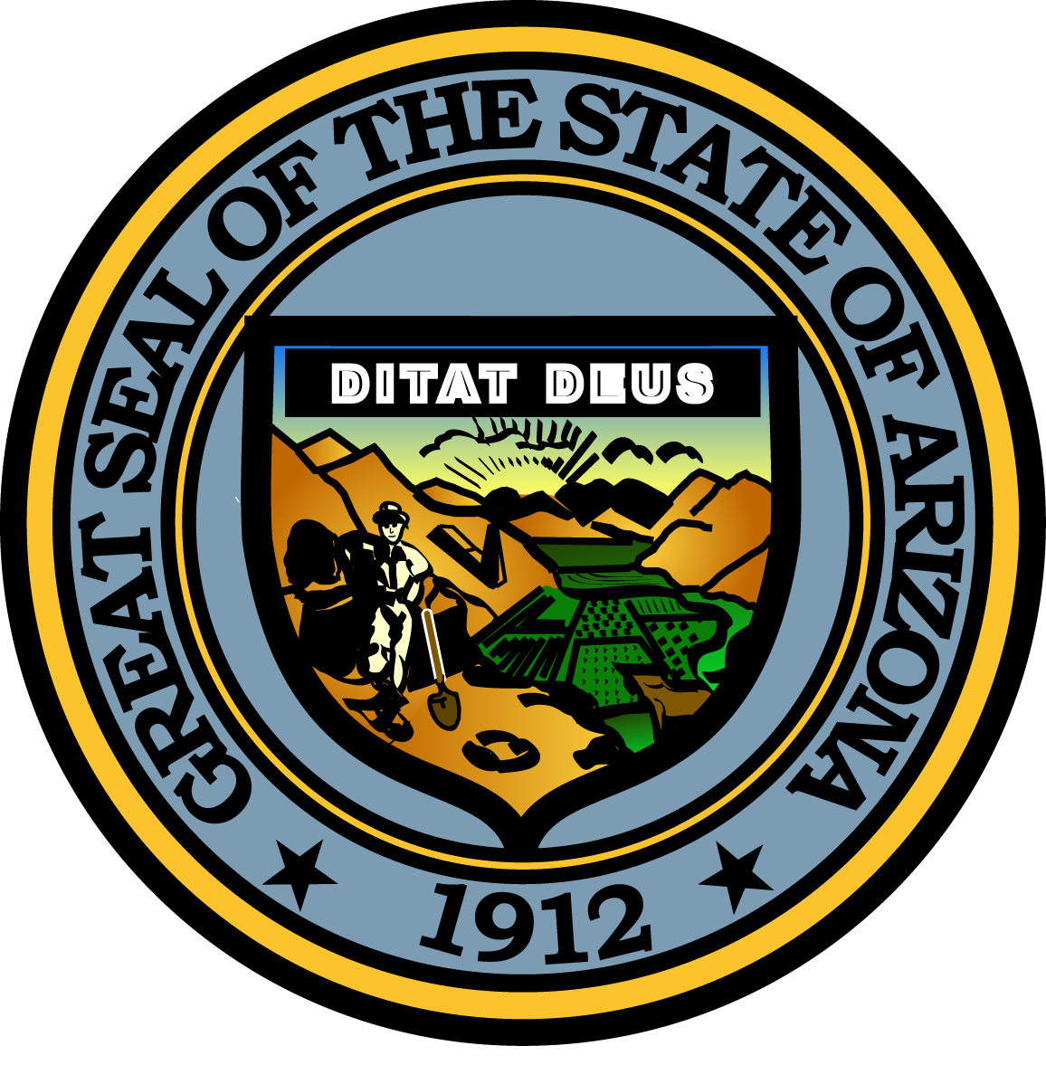

**Governor’s Council on Child Safety and Family Empowerment –**

**PARTNERSHIP SUBC0MMITTEE**

**May 19, 2017**

**1:00 PM**

**Casey Family Programs Office**

**378 E. Palm Lane, Phoenix, Arizona, 85004**

Pursuant to ARS 38-431.02 (A) (2), the Governor’s Council on Child Safety and Family Empowerment (Council) can vote to go into Executive Session for the purpose of discussion or considering documents exempt by law from public inspection and/or discussion or consultation for legal advice with its attorney.

Pursuant to A.R.S. § 38-431.01 (H), the Governor’s Council on Child Safety and Family Empowerment may obtain public comment pertaining to any of the listed agenda items if it so desires. A formal call to the public will take place at the end of the meeting.

**Meeting Agenda**

**Agenda Item**

|  |  |
| --- | --- |
| 1. **Welcome and Introductions** Janet Garcia, Casey FamilyPrograms 2. **Child Abuse License Plate Program**  * **Funding Status Update** Terrilyn Miller, GOYFF * **Awards Reception Update** * **Planning Discussion** Committee Members  1. **Collective Impact for Child Safety & Well-being** Janet Garcia 2. **Community Networks** Committee Members 3. **Member Updates** Committee Members 4. **Call to the Public** Janet Garcia 5. **Future Meeting Date and Adjournment** Janet Garcia |  |
|  |  |