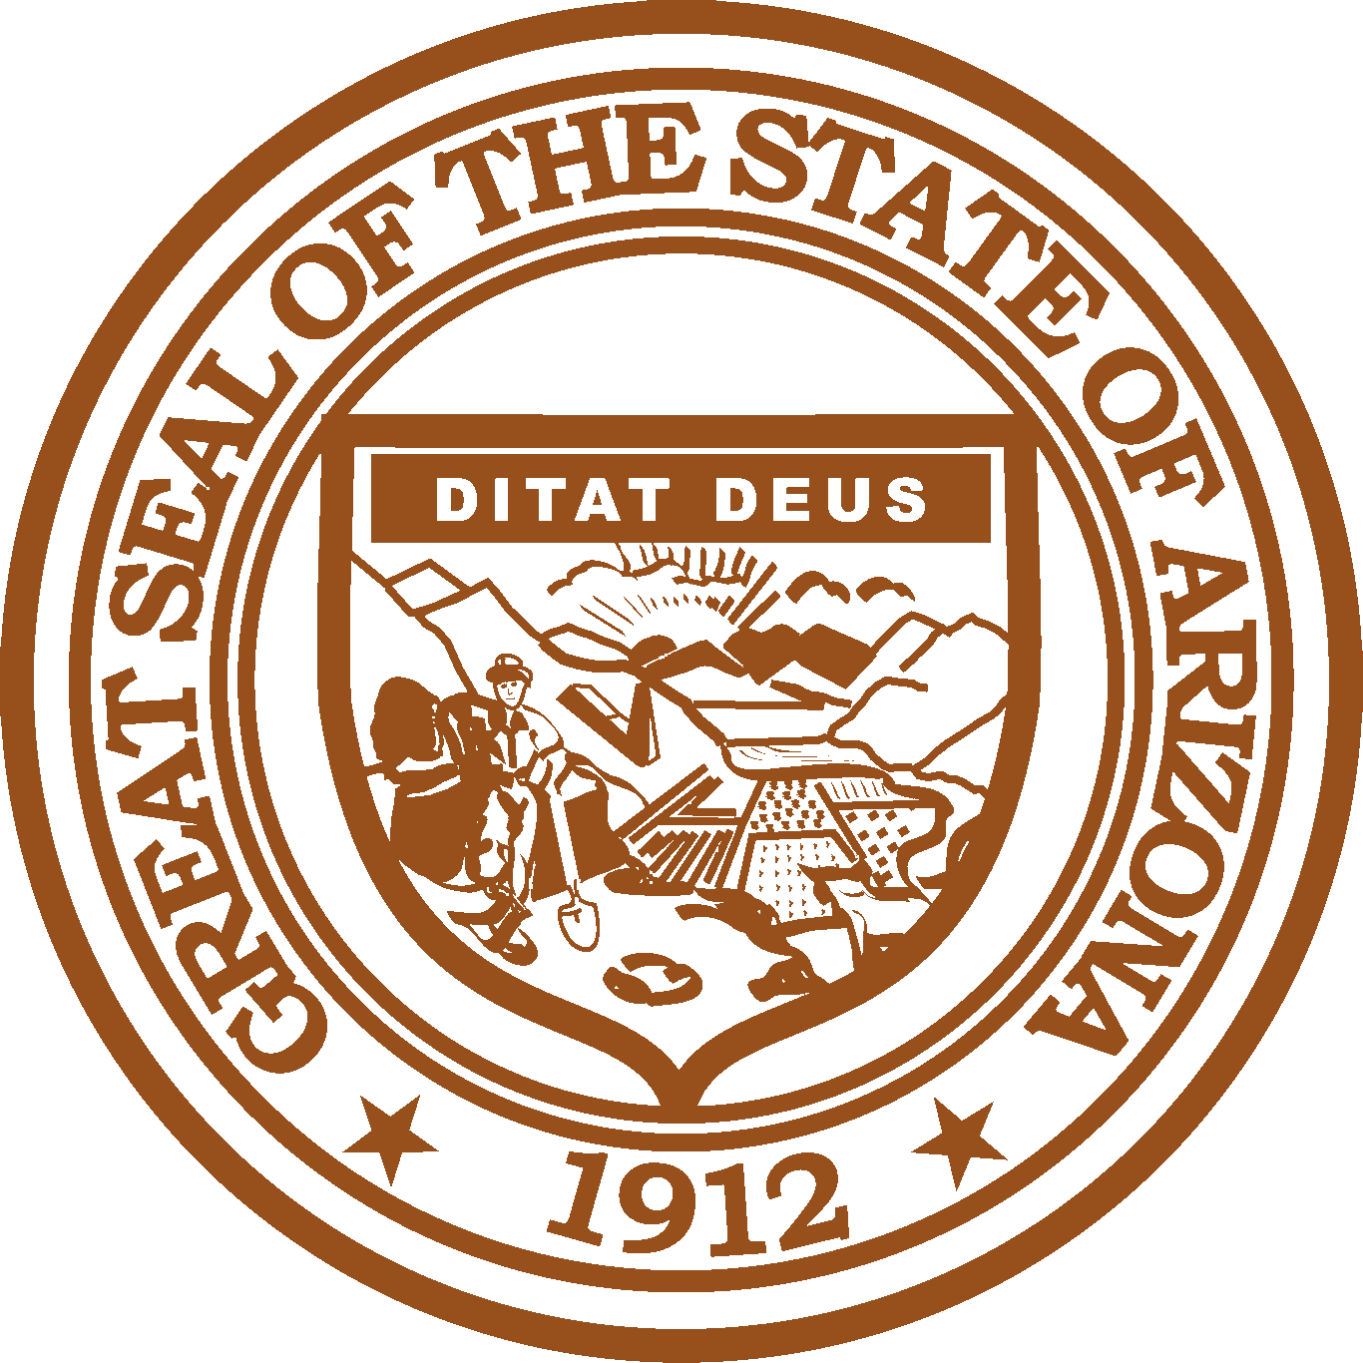

ARIZONA RECIDIVISM REDUCTION WORK GROUP OF THE
ARIZONA SUBSTANCE ABUSE PARTNERSHIP

May 15, 2019
4:00 PM
Governor’s Office of Youth, Faith and Family
1700 West Washington Street, Suite 230
Phoenix, Arizona 85007

Pursuant to ARS 38-431.02 (A) (2), the Recidivism Reduction Work Group of the Arizona Substance Abuse Partnership can vote to go into Executive Session for the purpose of discussion or considering documents exempt by law from public inspection and/or discussion or consultation for legal advice with its attorney.

Pursuant to A.R.S. § 38-431.01 (H), the Recidivism Reduction Work Group of the Arizona Substance Abuse Partnership may obtain public comment pertaining to any of the listed agenda items if it so desires. A formal call to the public will take place at the end of the meeting.

Meeting Agenda
Agenda Item |  | Anticipated Action
- Call to Order* | Mike Mitchell, Chair | Action
- Welcome/Introductions* | Mike Mitchell, Chair | Discussion
- Approval of Minutes* | Mike Mitchell, Chair | Action
- Grant Update* | Mike Mitchell, Chair | Discussion
- Management Plan/Substance Abuse Technology | Sam Burba, GOYFF | Discussion
- Future Agenda Items* | Mike Mitchell, Chair | Discussion
- Call to the Public* | Mike Mitchell, Chair | Discussion
- Adjourn*  *Standing agenda item. | Mike Mitchell, Chair | Action

Arizona Substance Abuse Partnership meeting agendas are subject to change up to 24 hours prior to the meeting. Supporting documentation related to agenda items is available by contacting Samuel Burba, Interim Director, Arizona Substance Abuse Partnership, Governor’s Office of Youth, Faith and Family at sburba@az.gov.

