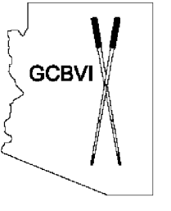
Speaker’s Card for Public Comment
Please complete and submit this card to Council staff if you wish to speak on an agenda item. No speaker card shall be accepted after the meeting is convened. Please keep your comments brief and concise (4) minutes.
Arizona Governor’s Council on Blindness and Visual Impairment (GCBVI)
1789 W. Jefferson Street. Phoenix, AZ 85007
Phone: (602) 364-1773
Attn: Council Staff
Email: GCBVI@azdes.gov

(Please Print)

Name: __________________________________________

Address: ________________________________________

Phone #: ________________________________________

Email: __________________________________________

Date: _______________ Agenda Item: _____________________________

The Chair may recognize speakers in agenda order. All comments shall be directed to the Council/Committee Chair. The Chair reserves the right to close public comment if comments have become repetitive or non-productive.

