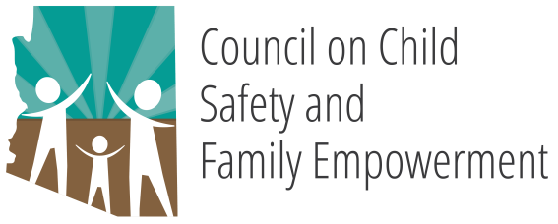

GOVERNOR DUCEY’S OFFICE OF YOUTH, FAITH AND FAMILY
COUNCIL ON CHILD SAFETY AND FAMILY EMPOWERMENT

SUPPORT SUBCOMMITTEE

April 16, 2019
10:30 AM

1700 West Washington Street Suite 230
Conference Room A
Phoenix, AZ 85007

Pursuant to ARS 38-431.02 (A) (2), the Governor’s Council on Child Safety and Family Empowerment can vote to go into Executive Session for the purpose of discussion or considering documents exempt by law from public inspection and/or discussion or consultation for legal advice with its attorney.

Pursuant to A.R.S. § 38-431.01 (H), the subcommittee may obtain public comment pertaining to any of the listed agenda items if it so desires. A formal call to the public will take place at the end of the meeting.

MEETING AGENDA
Agenda Item
- Call to Order | Berisha Black, Chair
- Introductions | Andrea Stuart, Co-Chair
- Approval of Minutes  March 16, 2019 | Andrea Start, Co-Chair
- ACEs Support Group | Subcommittee Members
- Next Meeting Agenda Items | Berisha Black, Chair
- Next Meeting Dates | Andrea Stuart, Co-Chair
May 21, 2019
June 18, 2019

- Call to the Public | Berisha Black, Chair
- Adjourn | Berisha Black, Chair

