Douglas A. Ducey Governor | Andy Tobin  Director
ARIZONA DEPARTMENT OF ADMINISTRATION
WATER QUALITY APPEALS BOARD
1840 W. JACKSON ST.
PHOENIX, ARIZONA 85007
TELEPHONE: (602) 542-1796
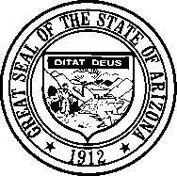

NOTICE AND AGENDA OF THE REGULAR MEETING OF THE ARIZONA WATER QUALITY APPEALS BOARD

Pursuant to Arizona Revised Statutes (A.R.S.) § 38-431.02, notice is hereby given to the members of the Water Quality Appeals Board and general public that the Arizona Water Quality Appeals Board (WQAB) will hold a regular meeting open to the public commencing on April 6, 2021 at 8:00 a.m. Meeting will be held virtually.

The following options will be available for public attendance. Details on available options and associated instructions are included below:

Google Meet - Join by phone
+1 929-287-3265 PIN: 934 003 585#
Google Meet - Video link
http://meet.google.com/xzj-tjnm-jbo

**NOTE: Members of the public do not need to have a Google account to participate in this meeting. **

*Please note that members of the public that choose to utilize Google Meet must keep their microphone muted for the duration of the meeting. If a member of the public wishes to speak, they may unmute their microphone by pressing *6.
The agenda for this meeting follows. Any amendments or additions to the agenda will be available at least 24 hours prior to the meeting. The Board officer presiding at the meeting reserves the right to change the order of items on the agenda, except for public hearings set for a specific time.
Pursuant to A.R.S. § 38-431.03(A)(3), the Board may vote to go into Executive Session to obtain legal advice from its attorney on any matter listed on the agenda. Executive sessions are not open to the public.

Pursuant to Title II of the Americans with Disabilities Act (ADA), the WQAB will not discriminate on the basis of disability in admission to and observation of its public meetings. Persons with a disability may request a reasonable accommodation such as a sign language interpreter, by contacting the Board’s Office at (602) 542-1553. Requests should be made as early as possible to allow time to arrange the accommodation.

- Call to order and roll call

- 21-002 Center for Biological Diversity & Dr. Kevin L. Gibson v. ADEQ, WQAB Appeal No. 21-002. The Board will discuss, consider, and possibly vote regarding the procedures to be applied to a future hearing by the Board or by the Board with referral to the Office of Administrative Hearing (“OAH”) for hearing, and prehearing dates for such process. Notice of the matter is provided to the parties with an opportunity to be heard.

DATED AND POSTED this 30th day of March 2021 at 4:00 p.m.

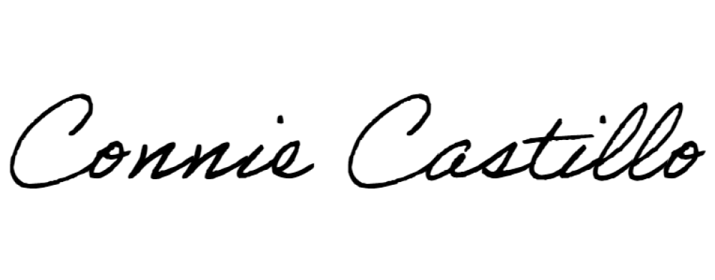
ARIZONA WATER QUALITY APPEALS BOARD

By: Connie Castillo, Clerk of the Board

A copy of the foregoing was emailed
This 30th day of March, 2021

ARIZONA WATER QUALITY APPEALS BOARD:
Michelle Van Quathem, Esq.
Fred E. Brinker, P.E. Keith Bowers

Dena R. Benjamin, Assistant Attorney General
James H. Rolstead, Assistant Attorney General
Arizona Attorney General’s Office
2005 N Central Ave., Phoenix, Arizona 85004
Attorneys for the Water Quality Appeals Board

